APDCAM Control   
User Guide

(Graphical User Interface for   
APDCAM and APDCAM-10G)

Version: 0.3

Last modified: 04.02.2016.

Table of Contents

**1.** **Introduction** 3

**2.** **Requirements** 3

**3.** **Using the software** 3

**3.1 Settings tab** 4

**3.2 Status tab** 5

**3.3 Measurement data tab** 5

**3.4 Measurement control** 6

**3.5 Camera infos** 6

**3.6 System log** 6

**4.** **Support** 7

1. **Introduction**

This document describes details about how to use APDCAM Control software. This software is capable to run under Windows and Linux as well.(Only Linux support for APDCAM-10G). APDCAM Control was tested under the following operating systems:

* Windows 7, 32-64bit
* Windows 8.1, 64bit
* Windows 10 Enterprice, 64bit
* CentOS 6, 64bit

1. **Requirements**
   * APDCAM or APDCAM-10G connected to a computer which is used to control one of the cameras.
   * Network settings necessary to communicate with APDCAM or APDCAM-10G.
   * Visual C++2013 Redistributables installed to be able to run the software (for windows only).
2. **Using the software**

The software can be started with provided APDCAMControl executable with double click on its icon or from command line as well. The software will display this window if no camera can be found.

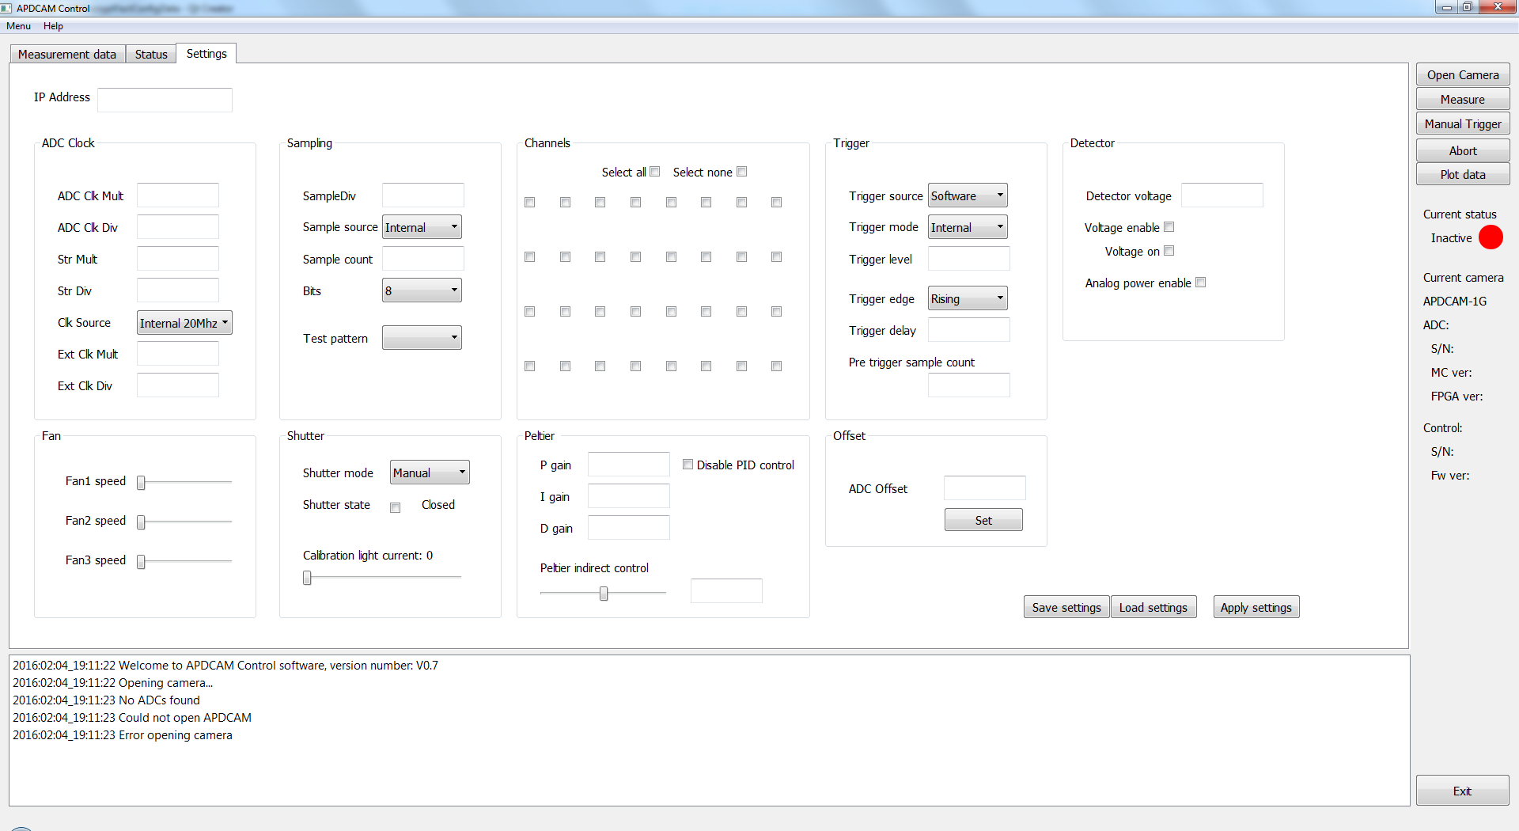

1 APDCAM Control default startup display

As we can see the software has 3 Tabs and 3 other areas, the „measurement control area”, the „camera info area” and the „system log”.

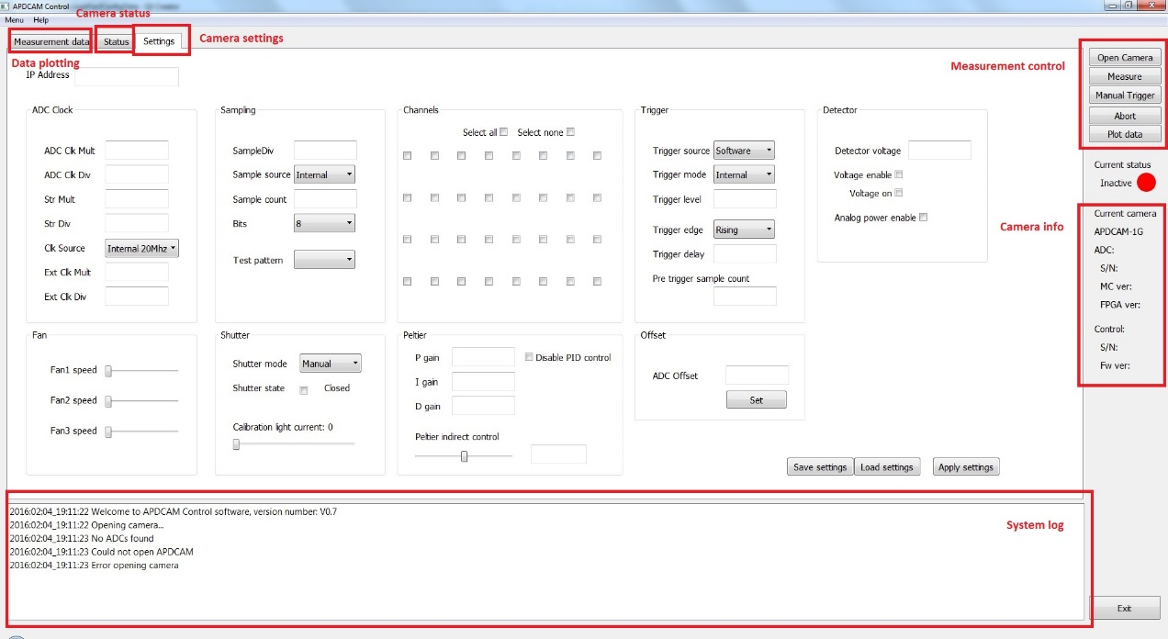

2 The main parts of the softwares main window

We will go through all of them in details.

**3.1 Settings tab**

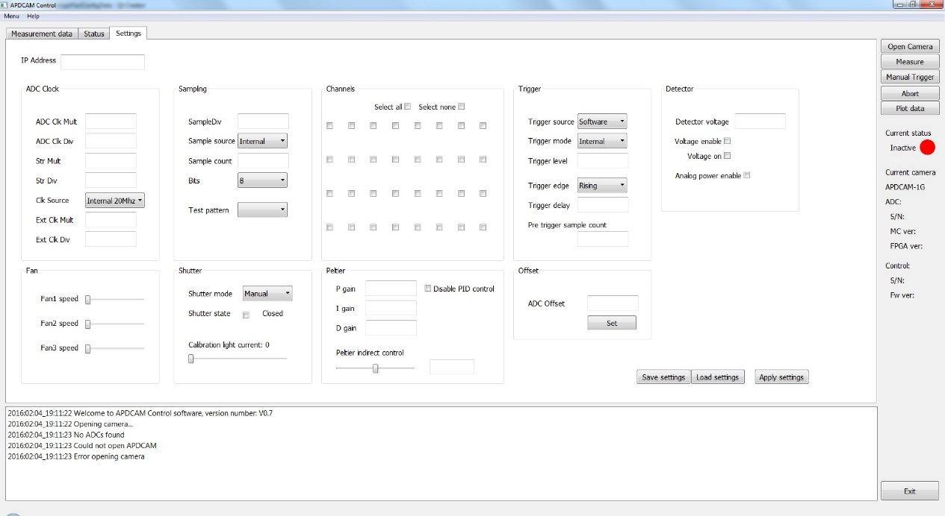

**3** Settings tab

**3.2 Status tab**

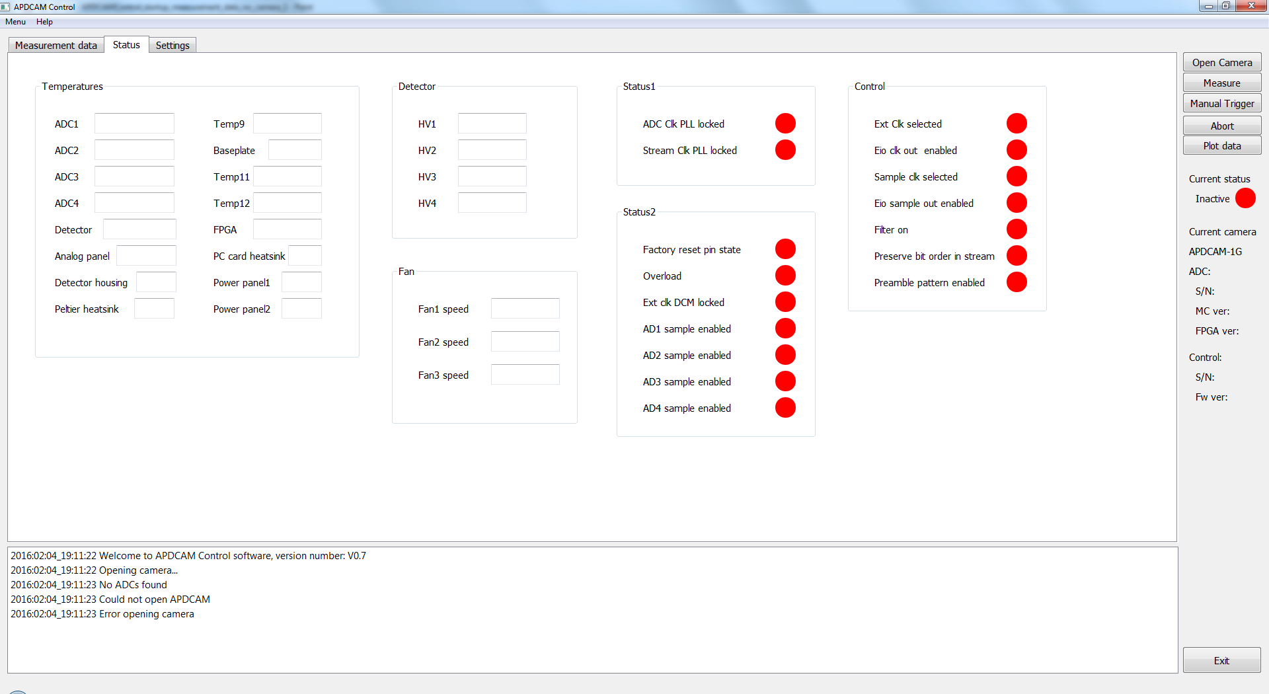

**4** Status tab

**3.3 Measurement data tab**

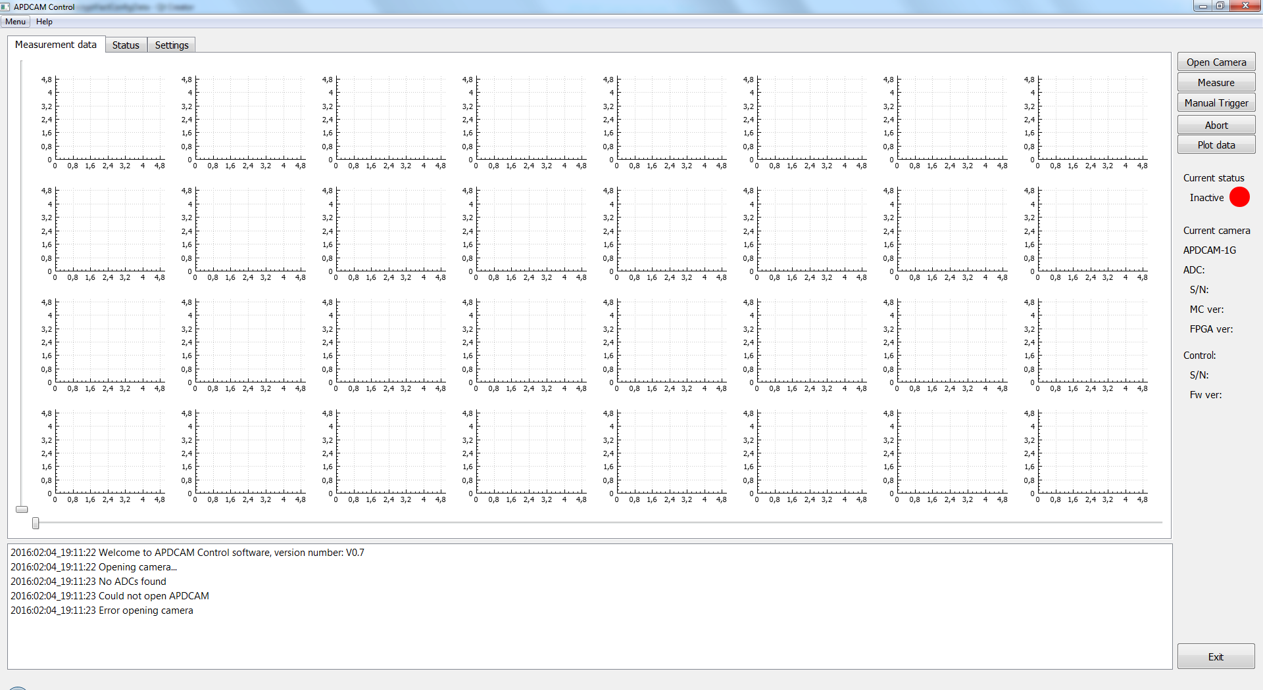

**5** Measurement data tab

**3.4 Measurement control**

**3.5 Camera infos**

**3.6 System log**

1. **Support**

If you have any further questions of want to report a bug please contact us by email:

[support@fusioninstruments.com](mailto:support@fusioninstruments.com?subject=APDCAM%20Control)